

**SYNOPSIS**

**ON**

**Performance Evaluation System for Students (PESS)**

**PREPARED BY**

Sajid Hussain

(FYMCA SEM. II, ROLL No.: 45)

**GUIDED BY**

Mrs. Anjana Arakerimath

(Head Of Department)

**SUBMITTED TO**

DEPARTMENT OF MCA

PIMPRI CHINCHWAD COLLEGE OF ENGINEERING

SECTOR NO. 26, PRADHIKARAN, NIGDI, PUNE - 44.

(2022-2023)

**INDEX**

1. **INTRODUCTION**
2. **OBJECTIVES**
3. **WORKING OF EXISTING SYSTEM**
4. **NEED OF NEW SYSTEM**
5. **USERS OF SYSTEM**
6. **WORKFLOW**
7. **TECHNICAL REQUIREMENTS**

* **HARDWARE**
* **SOFTWARE**

1. **OUTPUT SCREENS**
2. **REFERENCES**
3. **STUDENT DETAILS**
4. **INTRODUCTION**

Performance Evaluation System for Students (PESS) is a system wherein the teacher of a teaching institution gets the opportunity to manage and generate the performance report of each student easily. It is a platform where teachers can effectively manage and generate the overall performance of a student throughout the academic year based on the performance of students in terminal tests.

1. **OBJECTIVES**

The main objectives of Performance Evaluation System for Student (PESS) are:

* To Accept Students’ Details and Store them.
* To Accept the marks directly or in .csv format.
* To Accept Attendance Report in .csv format.
* To generate individual report cards of students.
* To let users view and download the report cards generated.
* To generate the rank list of students class-wise.

1. **WORKING OF EXISTING SYSTEM**

Currently, the teacher collects all the data, stores them in an excel file and then creates the marksheet based on the formulae used to calculate the percentage. This method is tedious and time consuming. It is prone to errors as the data generated in the excel file is then hand written into a report card. Here, the rank list is then generated by examining every report card.

1. **NEED OF NEW SYSTEM**

Presenting you with the new PESS, where some of the tasks of teachers are automated to reduce the probability of errors and the burden of teachers during report generations. Since the existing system is prone to errors and time consuming the new system aims at reducing the time taken to generate reports with maximum accuracy.

The benefits of new system are listed below:

* Reduces Time required for generating reports.
* Reduces Errors.
* Efficient in analyzing the performance of students.
* Aims at increasing the accuracy.
* Helps the owner to devise plans to increase the overall performance of the organization.
* Helps the owner to keep a check on the growth of the organization and its members.
* Helps the teachers in reducing their workload so that they can work more efficiently on their teaching techniques to improve their students’ performance.

1. **USERS OF SYSTEM**

* Owner of Organization
* Admin
* Teachers
* Students

1. **TECHNICAL REQUIREMENTS**

* **HARDWARE**

1. A computer with either Intel Pentium Processor or AMD Processor
2. 1GB DDR RAM or above
3. 40GB Hard Disk Drive

* **SOFTWARE**

1. Hyper Text Markup Language (HTML)
2. Cascading Style Sheet (CSS)
3. JavaScript
4. PostgreSql
5. Express Js
6. React Js
7. Node Js
8. **WORKFLOW**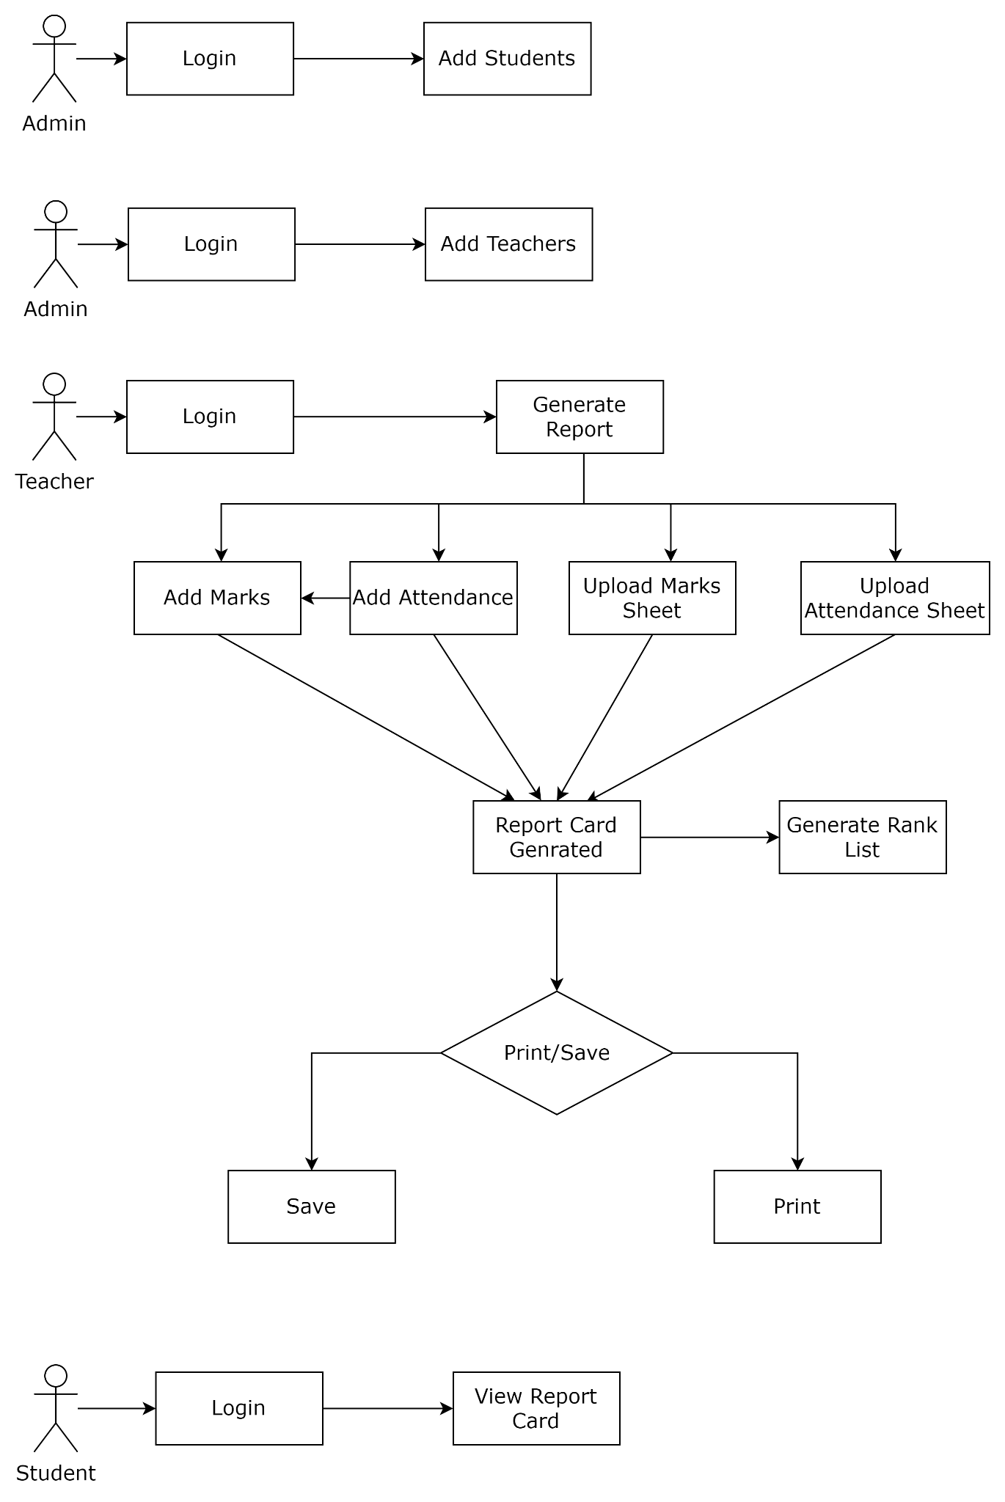
9. **OUTPUT SCREENS**

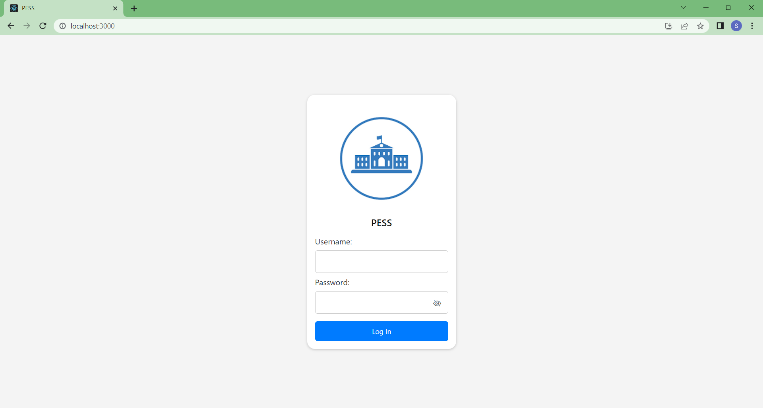

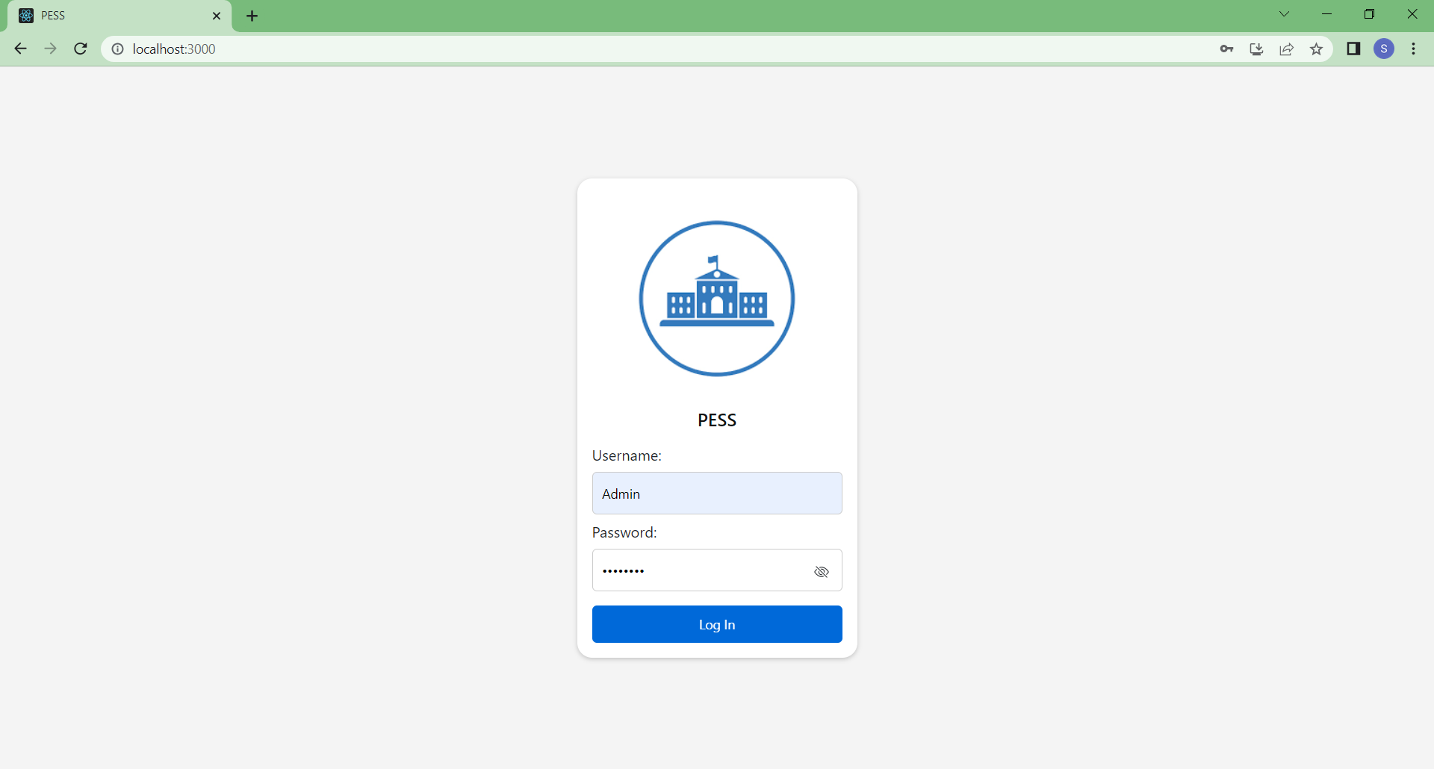

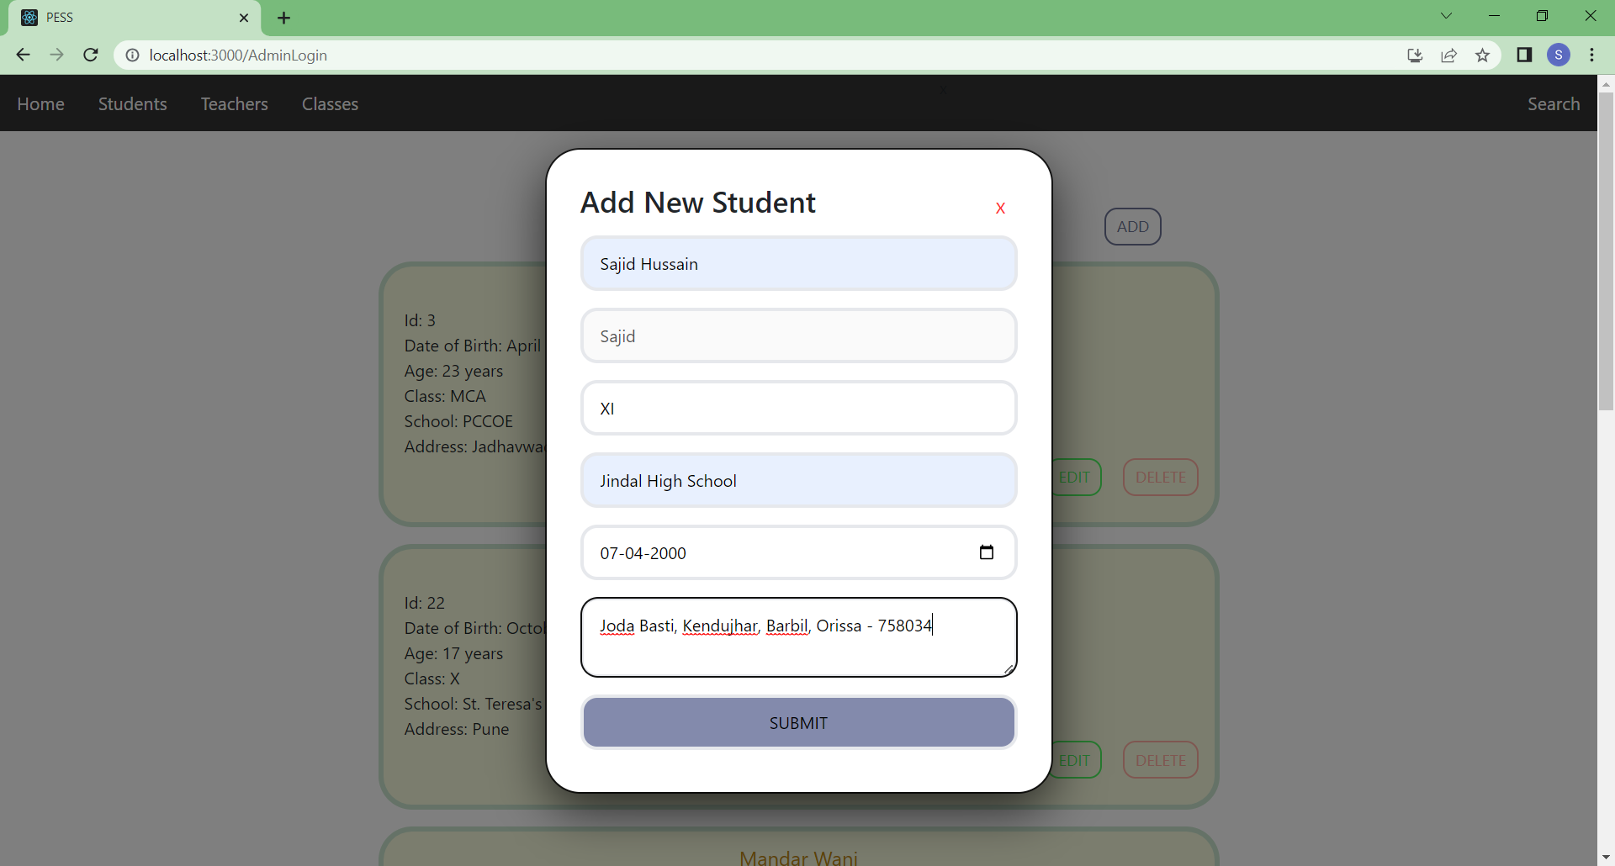

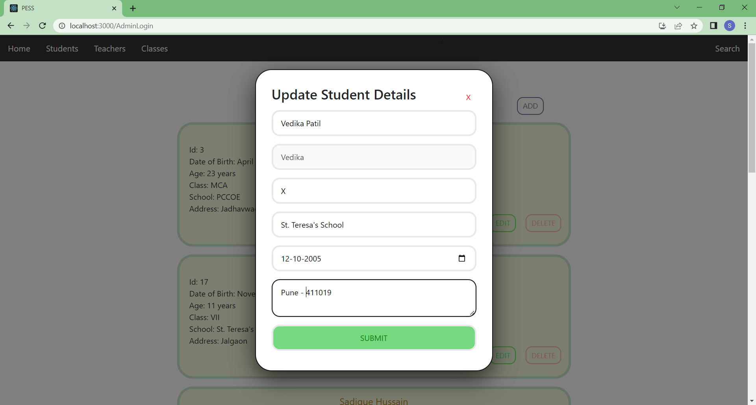

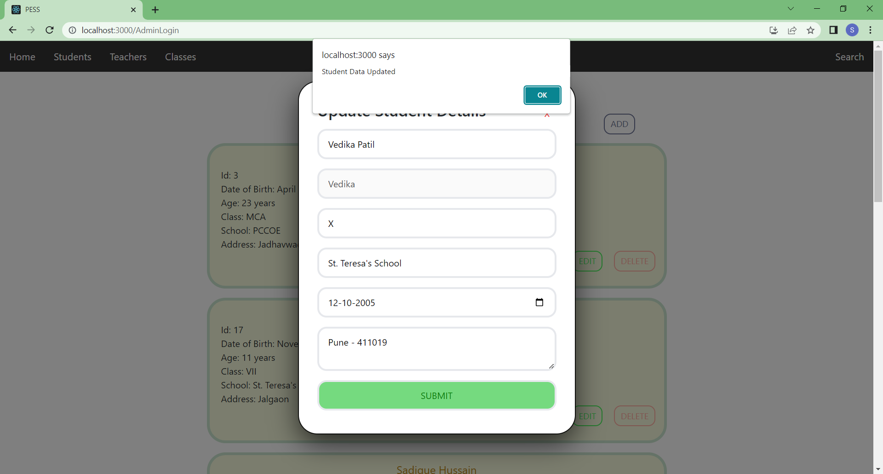

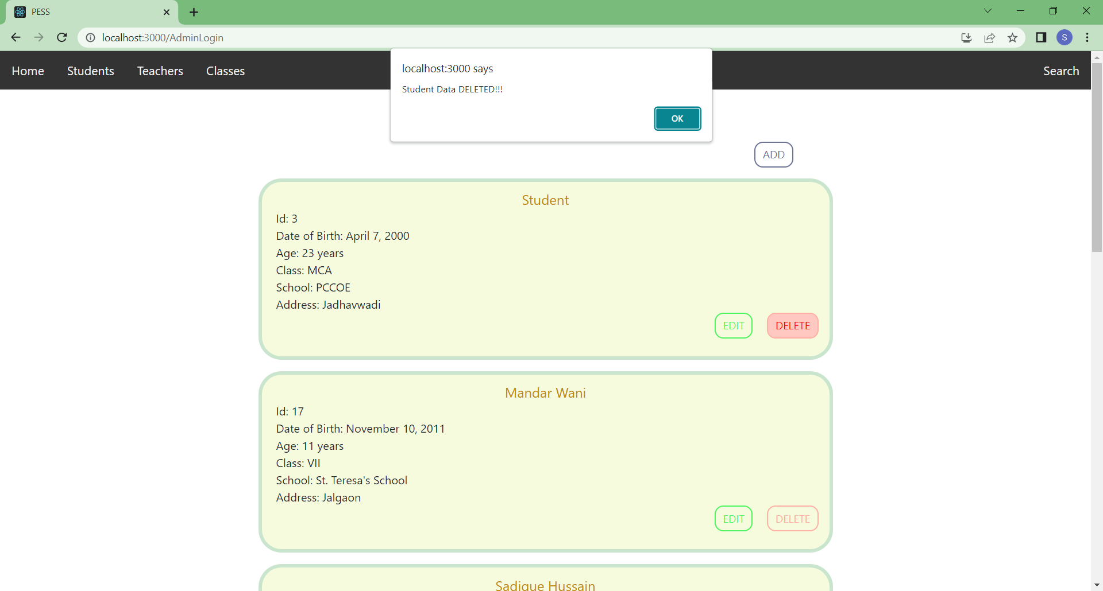

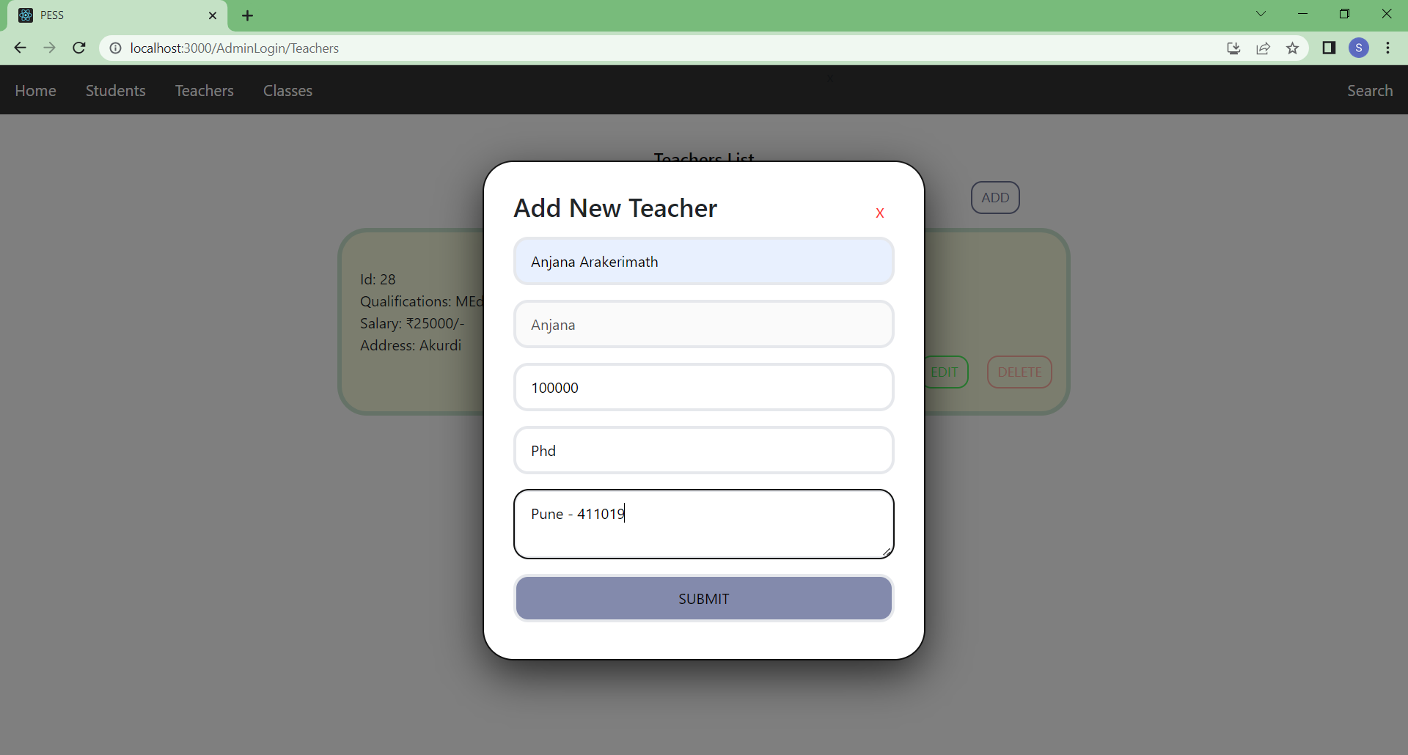

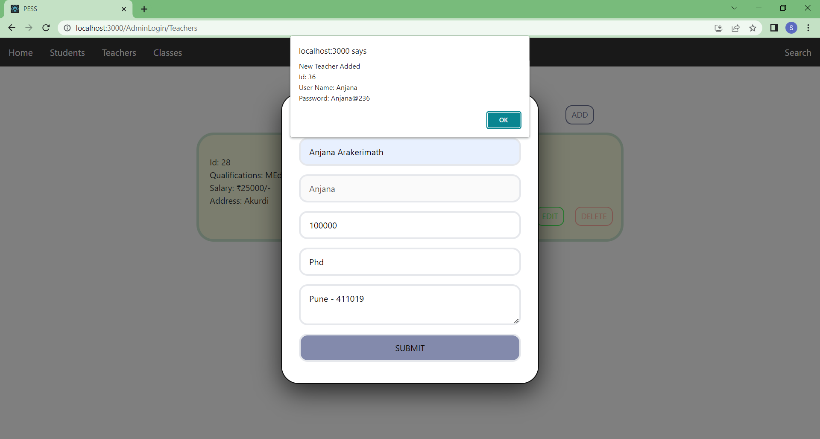

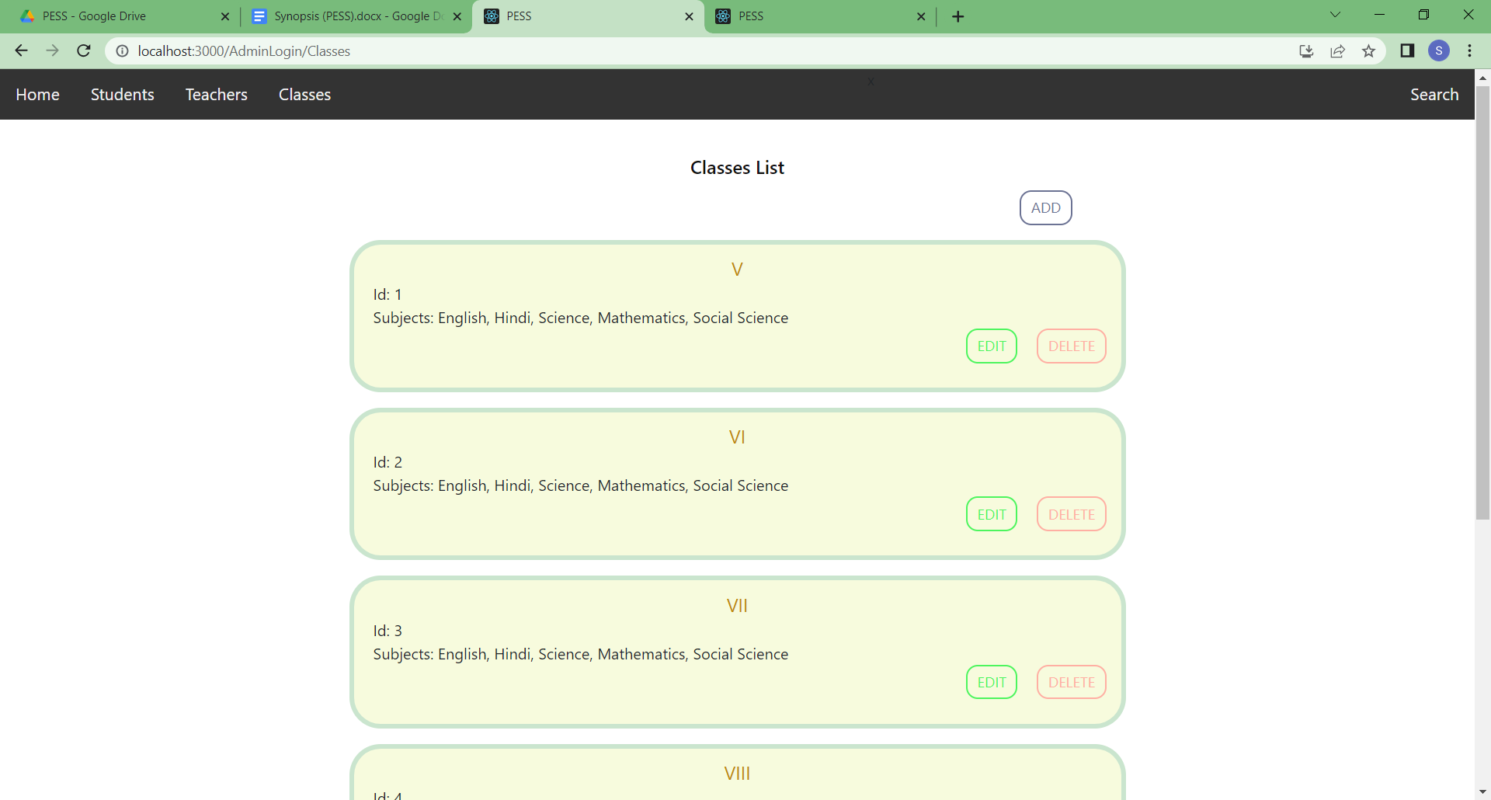

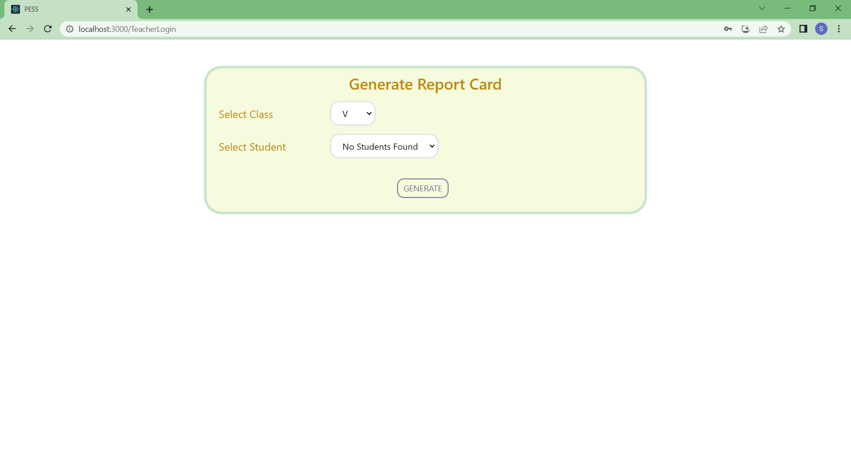

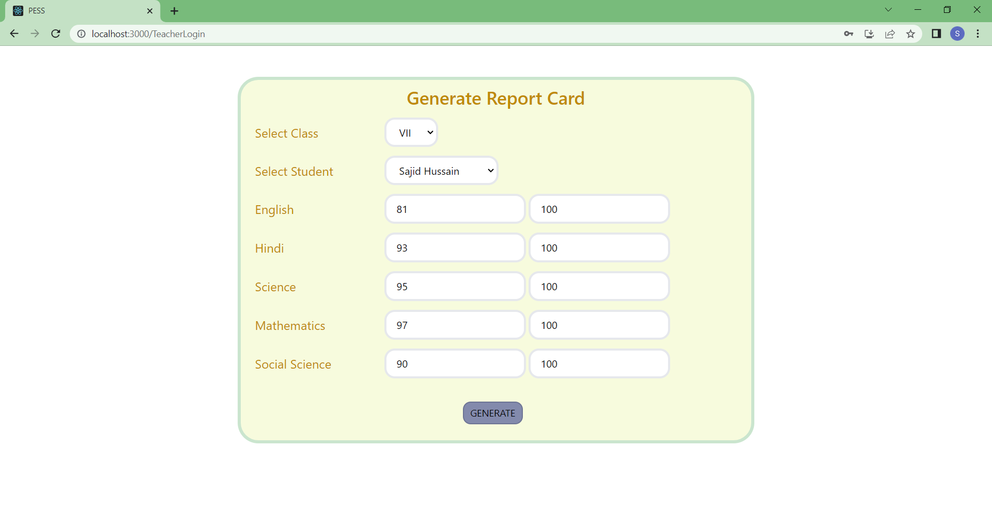

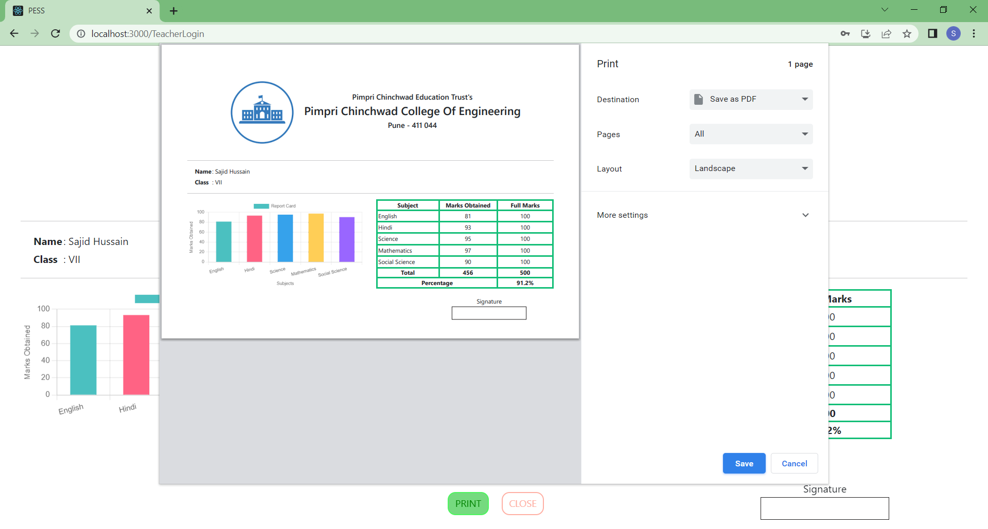

1. **REFERENCES**

* **BOOK REFERENCE**
  1. Head First Web Development
  2. PostgreSql: Introduction and Concepts
  3. Eloquent JavaScript, 3rd Edition: A Modern Introduction to Programming
  4. A Smarter Way to Learn JavaScript
* **WEBSITE REFERENCE**
  1. [www.geeksforgeeks.org](http://www.geeksforgeeks.org)
  2. [www.w3schools.com](http://www.w3schools.com)
  3. [www.programiz.com](http://www.programiz.com)
  4. www.youtube.com

1. **STUDENT DETAILS**

NAME OF STUDENT : Sajid Hussain

ROLL NUMBER : FYMCA - 45

PRN : 122M1H045

E - MAIL : [sajid.hussain22@pccoepune.org](mailto:sajid.hussain22@pccoepune.org)

CONTACT NUMBER : 86579 50509